Non-Zippered TRAM Flap Girdle

**Style 1450 – $121.70 – $141.70**

**Ideal For:** DIEP flap procedure

### **Size Chart – How to measure**

#### Waist 🡪 Measure around the narrowest part of the waistline around or above the navel.

#### Lower Hip 🡪 Measure around the fullest part of the lower hip area, keep tape measure parallel to the floor.

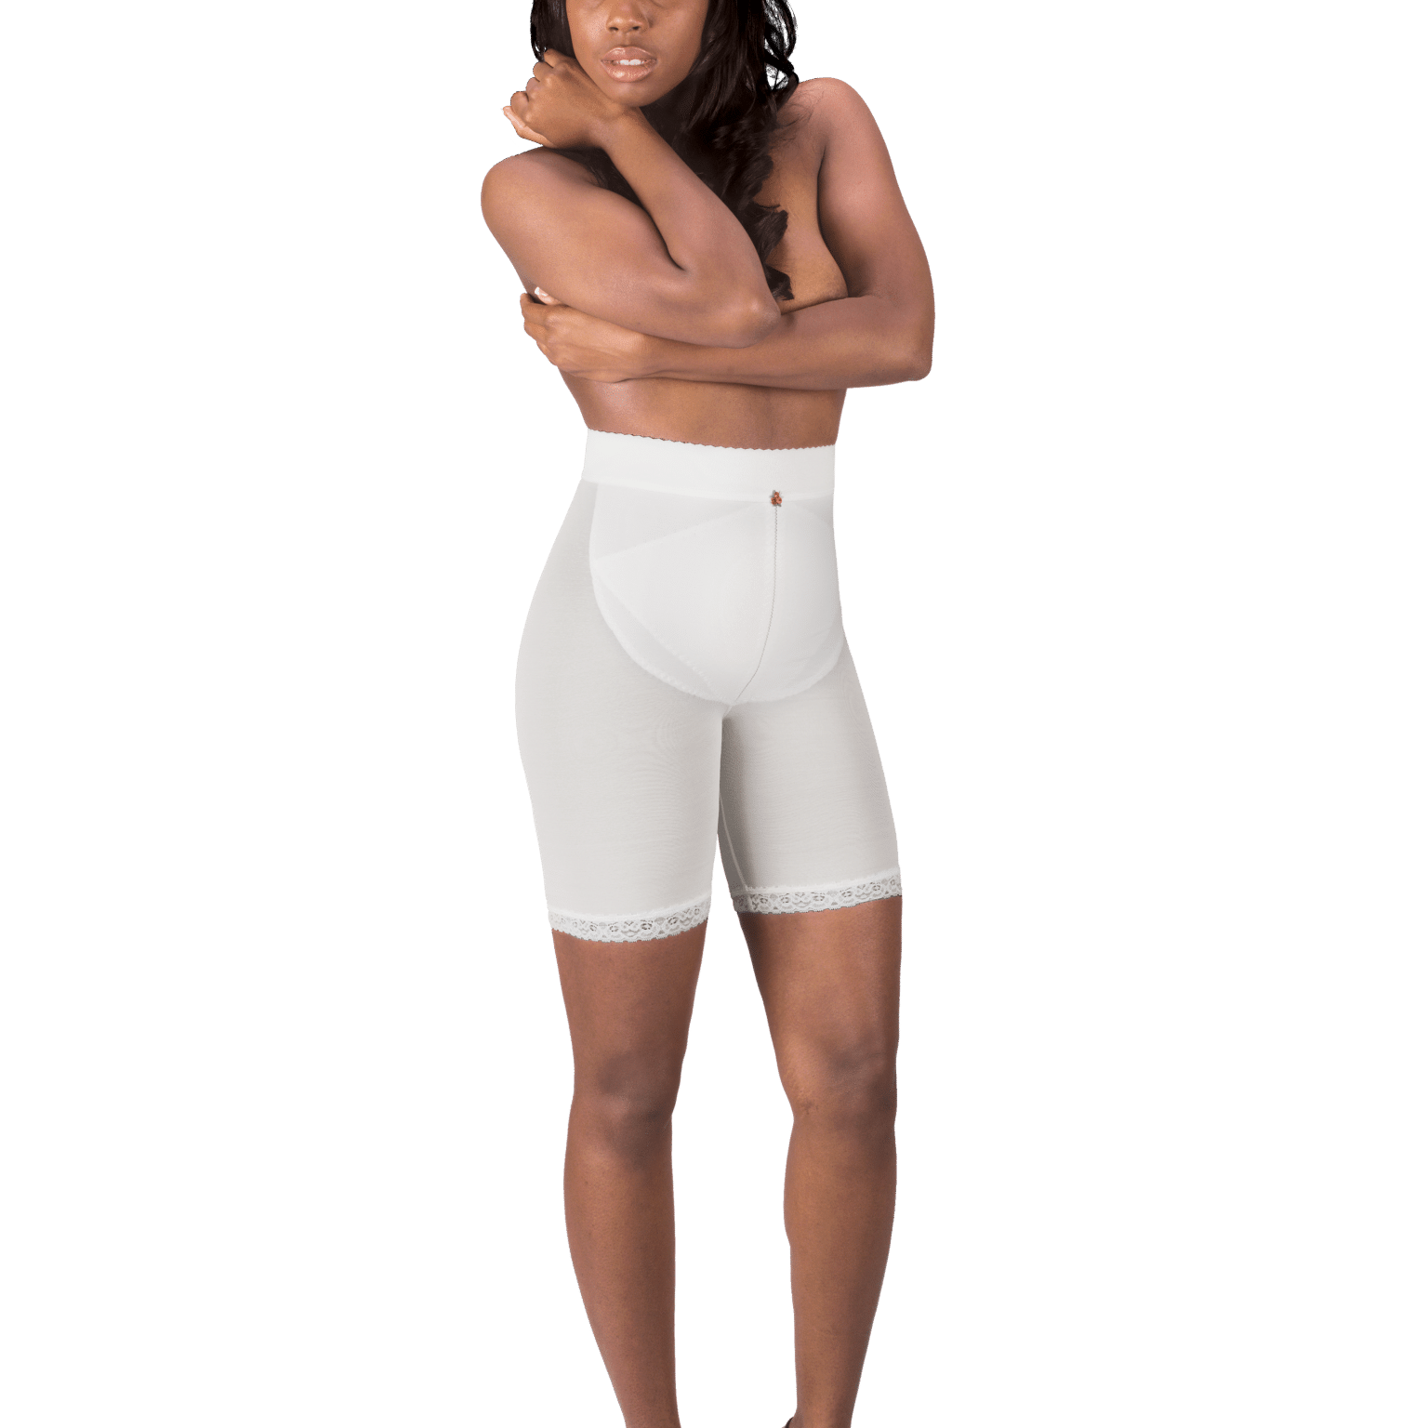

| **Size** | **Waist** | **Hip/Thigh** |
| --- | --- | --- |
| XS | 21″ – 23″ | 31″ – 33″ |
| S | 24″ – 26″ | 34″ – 36″ |
| M | 27″ – 29″ | 37″ – 39″ |
| L | 30″ – 32″ | 40″ – 42″ |
| XL | 33″ – 35″ | 43″ – 45″ |
| 2XL | 36″ – 39″ | 45″ – 48″ |
| 3XL | 40″ – 43″ | 49″ – 52″ |
| 4XL | 44″ – 47″ | 53″ – 56″ |

**To order call:** [**800.442.5800**](tel:8004425800) **or order online @** [**Design Veronique**](https://www.designveronique.com/post-surgical/original-girdles/non-zippered-tram-flap-girdle/) **designveronique.com**

Use code **DR4785** during the checkout process to receive 15% off the retail pricing.  This code cannot be combined with other discounts.